TABLE OF CONTENT
Introduction …………………………………………………………………………………….2
(Software development life cycle) SDLC………………………………………………3
System Architecture Design……………………………………………………………….5
Component Interaction……………………………………………………………….6
Prototype development…………………………………………………………………….14
Git and GitHub integration……………………………………………………………..…24
Project management: Hydro Alert SL Deployment………………………………25
Gantt chart…………………………………………………………………………………26
Network diagram………………………………………………………………………..28
License, Design Quality & SDG Relevance…………………………………………29
Conclusion ……………………………………………………………………………………35
Reference……………………………………………………………………………………..34

INTRODUCTION
In Sierra Leone, access to reliable, clean drinking water remains a critical challenge, particularly in rural and semi-urban communities within districts such as Kambia, Bonthe, and Pujehun. Community water pumps serve as vital lifelines, yet traditional infrastructure maintenance is heavily reactive. When a pump breaks down, weeks can pass before a supervisor is notified, a technician is dispatched, or spare parts are procured. This lack of visibility directly contributes to prolonged water scarcity and asset degradation.
HydroAlert SL is designed as a digital public good system (DPG) to transform this workflow into a proactive, data-driven cycle. By combining IoT (Internet of Things) telemetry hardware with an intuitive cloud-based management platform, HydroAlert SL continuously monitors physical pump health (such as water flow rates and sensor battery levels). When issues occur, the system automatically routes real-time alerts to supervisors and dispatches localized field technicians. This comprehensive documentation outlines the system's software development lifecycle, multi-tier architecture, visual prototypes, version control mechanics, and alignment with global sustainable development initiatives.

(Software development life cycle) SDLC
Chose model: AGILE model
Agile refers to something that is quick or adaptable. A software development approach based on iterative development is an “agile process model.” Agile approaches divide projects into smaller iterations or sections and avoid long-term planning. The scope and requirements of the project are discovered at the start of the development phase
The four essential values of agile software development
- Interactions between individuals and groups about processes and tools
- Working software takes precedence over thorough documentation.
- Collaboration with customers is preferred over contract negotiations.
- Adapting to change in accordance with a strategy
Our system was based on this model because the system involves IoT (internet of things) hardware and software updates, and user needs (community, technicians, supervisors) may evolve. The system progress is much more successfully with the requirement or feedback from the users and management.
Requirement | Interview water authority managers, technicians, and villagers in Sierra Leone (e.g., Kambia, Bonthe, Pujehun districts). Identify needs: real‑time pump status, automatic fault alerts, technician assignment, work order tracking, and simple UI for low‑literacy users. Write user stories (e.g., “As a supervisor, I want to see all faulty pumps on a dashboard so I can dispatch help quickly”).
Design | Create system architecture (IoT sensors → cloud → dashboard). Design database schema (pumps, alerts, technicians, work orders). Build low‑fidelity wireframes, then high‑fidelity Figma prototype. Review with stakeholders and adjust before coding.
Development | Divide work into 2‑week sprints. Example: • Sprint 1: Backend API to receive sensor data and store pump status. • Sprint 2: Dashboard with summary cards and alerts list. • Sprint 3: Technician assignment and work order system. • Sprint 4: Notification service (SMS to technicians). • Sprint 5: Integration of IoT sensor hardware and end‑to‑end testing.
Testing | Testing After each sprint, run unit tests (e.g., does an alert generate when flow = 0?), integration tests (does SMS actually send?), and usability tests with real technicians. Fix bugs in the next sprint.
Deployment | Pilot in one district (Kambia) with 10 pumps. Monitor for 2 weeks. Then scale to all districts.
Maintenance | Ongoing maintenance: replace sensor batteries, update software based on user feedback, and add new features (e.g., map view, spare parts inventory).

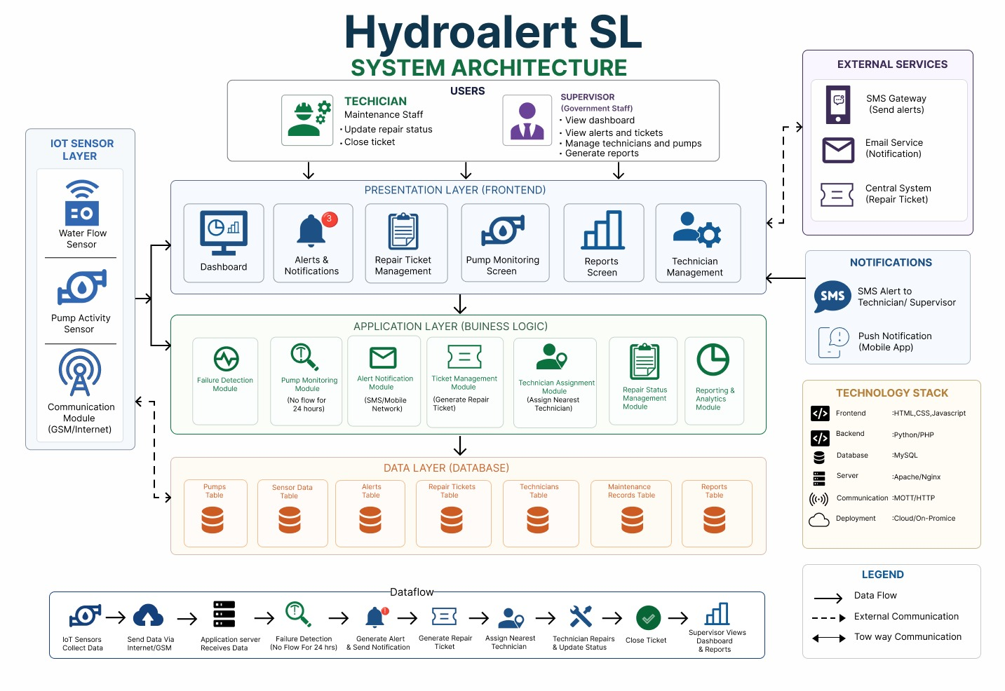
System Architecture Design

Hydroalert SL System Architecture components
1. IoT Sensor Layer
This is the data collection layer. Sensors installed in the field monitor water pumps and send information to the system.
Water Flow Sensor
- Measures water flow in pipes.
- Detects whether water is flowing normally.
- If no flow is detected for a long period, it may indicate a pump failure.
Pump Activity Sensor
- Monitors whether the pump is running.
- Tracks operational status and performance.
Communication Module (GSM/Internet)
- Sends sensor data to the application server.
- Uses GSM or Internet connectivity.
2. Users
Two categories of users interact with the system.
Technician (Maintenance Staff)
Responsibilities:
- Update repair status.
- Receive assigned jobs.
- Close repair tickets after fixing issues.
Supervisor (Government Staff)
Responsibilities:
- View dashboards.
- Monitor alerts and repair tickets.
- Manage pumps and technicians.
- Generate reports.

3. Presentation Layer (Frontend)
This layer is the user interface that users see and interact with.
Dashboard
- Displays overall system status.
- Shows pump health and statistics.
Alerts & Notifications
- Displays warnings and system alerts.
- Notifies users when faults occur.
Repair Ticket Management
- Shows repair requests.
- Tracks ticket progress.
Pump Monitoring Screen
- Provides real-time information about pumps.
- Shows operating conditions.
Reports Screen
- Displays historical records and analytics.
Technician Management
- Allows supervisors to manage maintenance personnel.

4. Application Layer (Business Logic)
This layer contains the intelligence of the system.
Failure Detection Module
- Analyzes incoming sensor data.
- Detects abnormalities and failures.
Pump Monitoring Module
- Checks if water flow stops.
- Example:
  - No flow for 24 hours = possible fault.
Alert Notification Module
- Sends notifications through:
  - SMS
  - Mobile network
Ticket Management Module
- Automatically creates repair tickets when a problem is detected.
Technician Assignment Module
- Assigns the nearest or available technician to the repair task.
Repair Status Management Module
- Tracks repair progress.
- Updates ticket status.
Reporting & Analytics Module
- Generates summaries and statistics.
- Produces performance reports.

5. Data Layer (Database)
This layer stores all system information.
Pumps Table
Stores:
- Pump ID
- Location
- Status
Sensor Data Table
Stores:
- Flow readings
- Pump activity data
- Timestamps
Alerts Table
Stores:
- Alert messages
- Alert time
- Severity level
Repair Tickets Table
Stores:
- Ticket number
- Fault description
- Current status
Technicians Table
Stores:
- Technician information
- Contact details
- Assigned tasks

Maintenance Records Table
Stores:
- Repair history
- Maintenance activities
Reports Table
Stores:
- Generated reports
- Statistical summaries
6. External Services
These are third-party services used by Hydroalert SL.
SMS Gateway
- Sends SMS alerts to technicians and supervisors.
Email Service
- Sends email notifications.
Central System
- Integrates with external repair management systems.
7. Notifications
The system communicates with users through:
SMS Alerts
- Sent to technicians and supervisors when faults are detected.
Push Notifications
- Delivered through the mobile application.

8. Technology Stack
These technologies are used to build the system.
Layer | Technology
Frontend | HTML, CSS, JavaScript
Backend | Python
Database | MySQL
Server | Apache or Nginx
Communication Protocol | MQTT / HTTP

9. System Data Flow
The overall process works as follows:
Step 1: Sensors Collect Data
- Water flow and pump activity sensors gather information.
Step 2: Data Transmission
- Information is sent through GSM or the Internet.
Step 3: Application Server Receives Data
- The backend receives and processes the sensor readings.
Step 4: Failure Detection
- If no water flow is detected for 24 hours, the system identifies a possible fault.
Step 5: Alert Generation
- SMS and notifications are sent automatically.
Step 6: Repair Ticket Creation
- A maintenance ticket is generated.
Step 7: Technician Assignment
- The nearest available technician is assigned.
Step 8: Repair and Status Update
- The technician fixes the problem and updates the ticket.
Step 9: Ticket Closure
- The issue is marked as resolved.
Step 10: Reporting
- Supervisors review dashboards and generate reports.
Overall Architecture Pattern
The Hydroalert SL system follows a layered architecture:
- IoT Sensor Layer → Collects data.
- Presentation Layer → Provides the user interface.
- Application Layer → Processes business logic.
- Data Layer → Stores information.
- External Services → Handles communication and notifications.
This design separates responsibilities, making the system easier to maintain, scale, and secure.

Prototype development
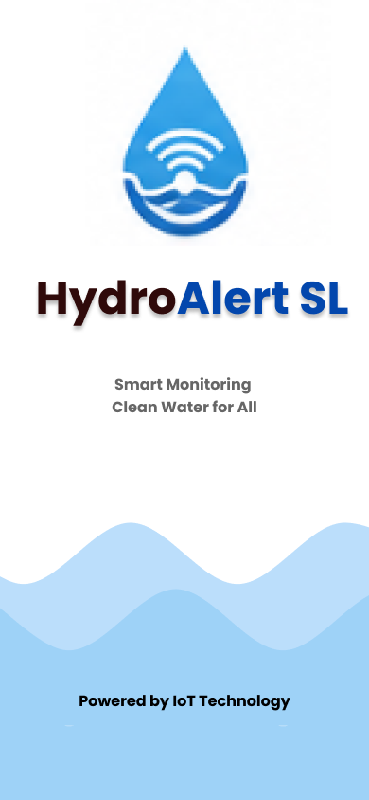
opening screen Page

Login screen Page
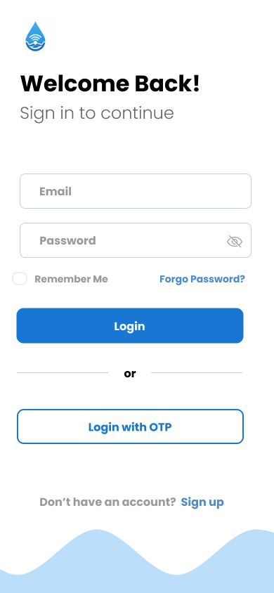

Dashboard Page
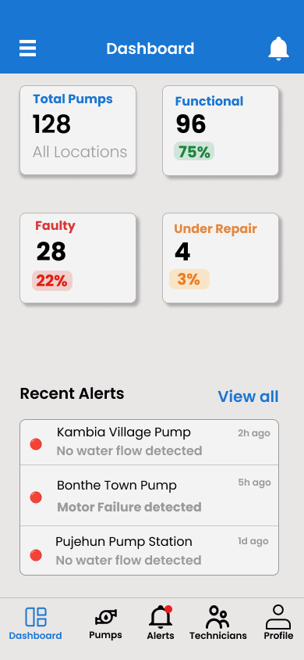

Pump status Map
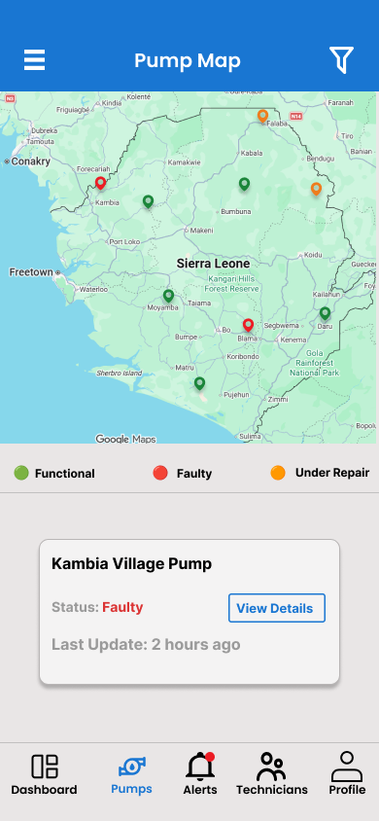

Pump details page
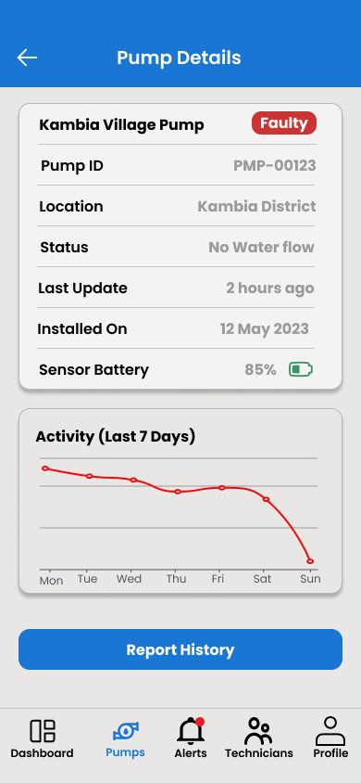

Alerts Page
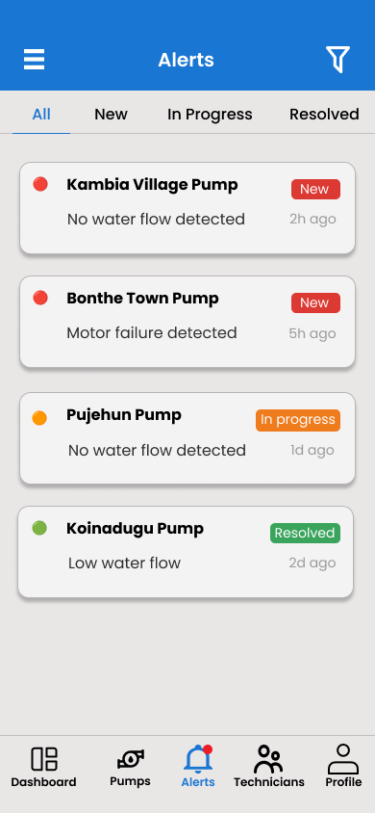

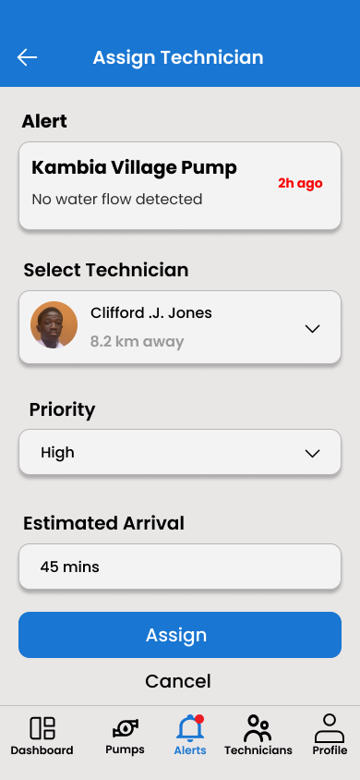
Assigned technician page

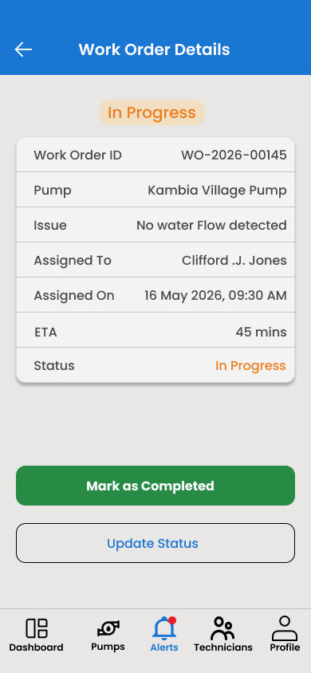
Work order detail page

Technician page
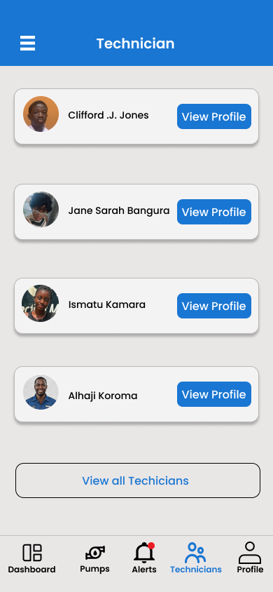

View Technician Profile Page
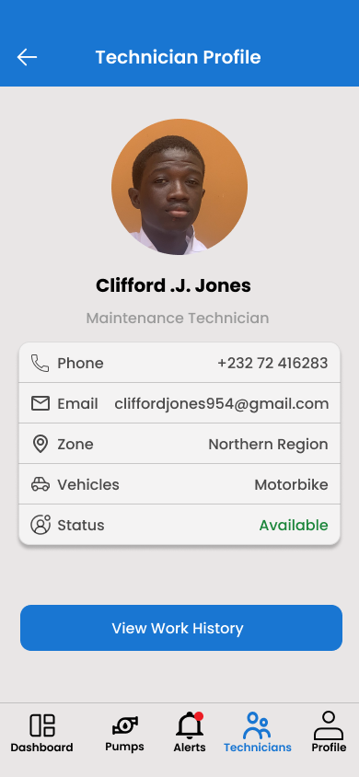
Profile Page
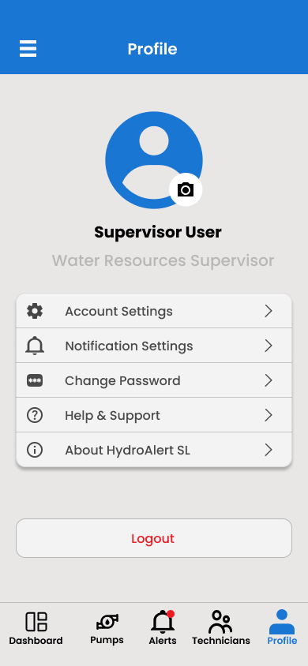

GitHub integration

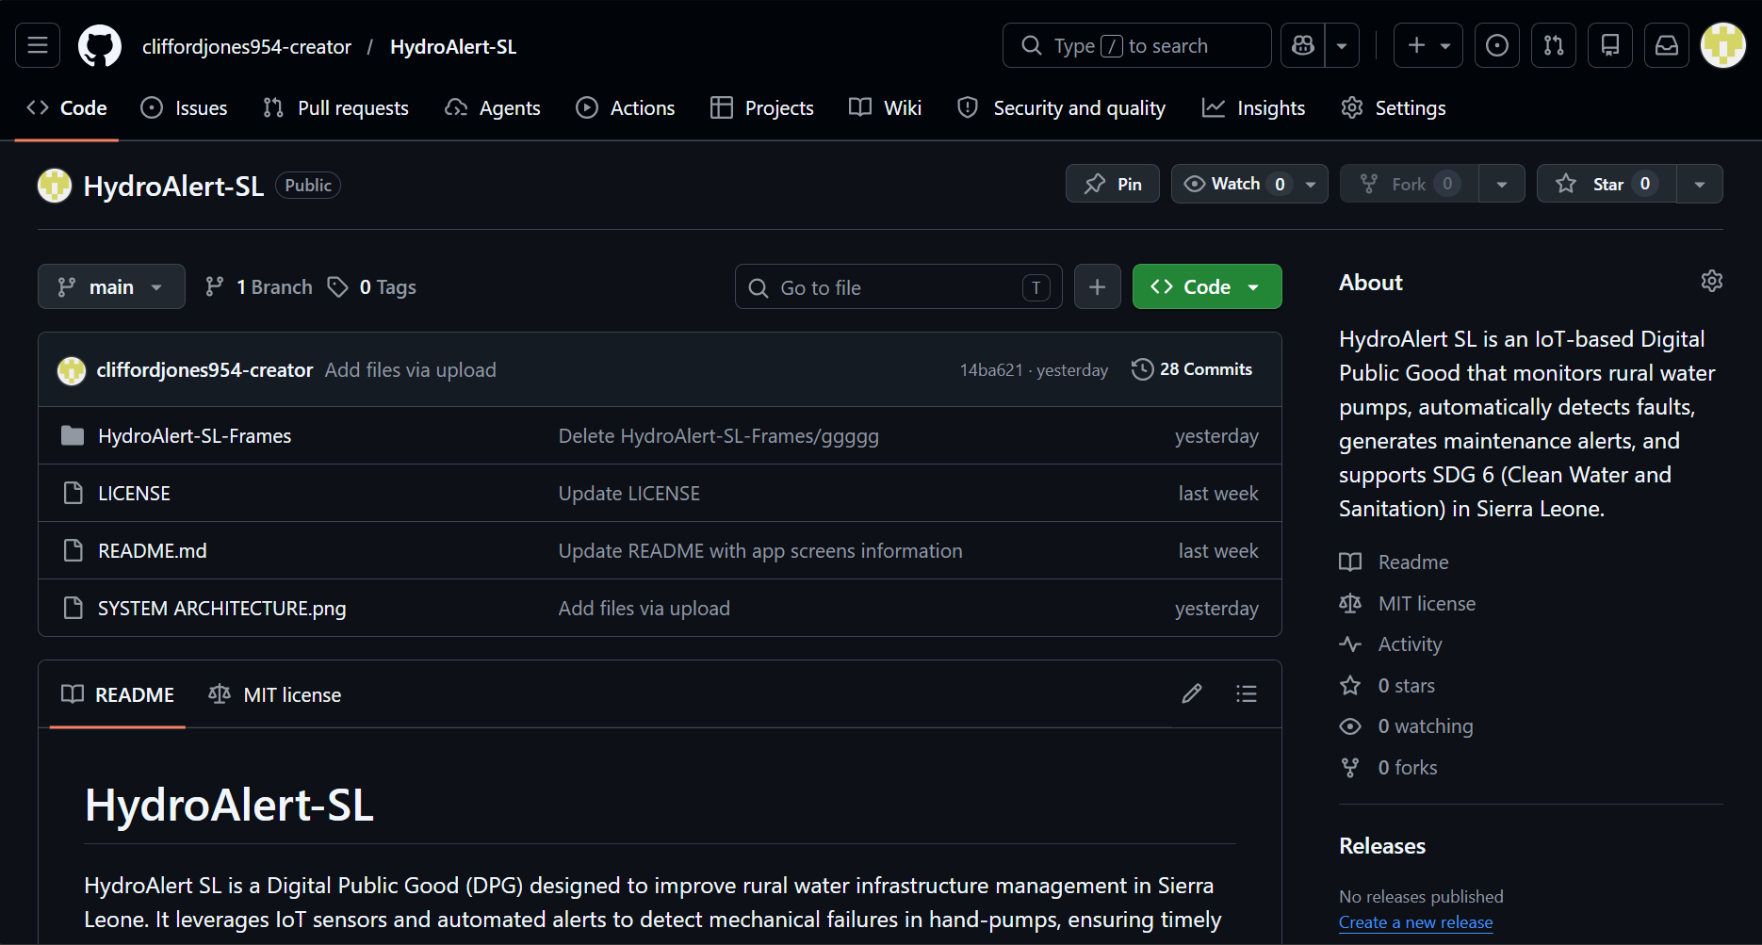

Project management: Hydro Alert SL Deployment
PROJECT ID | ACTIVITY | DELIVERABLES | DURATION(WEEK)
A | Requirements Gathering and Project Planning | Requirements Specification Document | W1
B | System Analysis and Design (Architecture, Database, UI Mockups) | System Design Document | W2
C | IoT Hardware Setup and Sensor Integration | Functional IoT Prototype | W3
D | Backend Development (Database and API Development) | Backend Services Developed | W4
E | Frontend Dashboard Development | User Dashboard Prototype | W5
F | Alert and Notification Module Integration | Real-Time Alert System | W6
G | System Testing, Debugging, and Performance Evaluation | tested and Validated System | W7
H | Deployment, User Training, Documentation, and Project Closure | final Working System and Documentation | W8

Gannt chart
Task ID | activity | W1 | W2 | W3 | W4 | W5 | W6 | W7 | W8
A | Requirements Gathering and Project Planning
B | System Analysis and Design (Architecture, Database, UI Mockups)
C | IoT Hardware Setup and Sensor Integration
D | Backend Development (Database and API Development)
E | Frontend Dashboard Development
F | Alert and Notification Module Integration
G | System Testing, Debugging, and Performance Evaluation

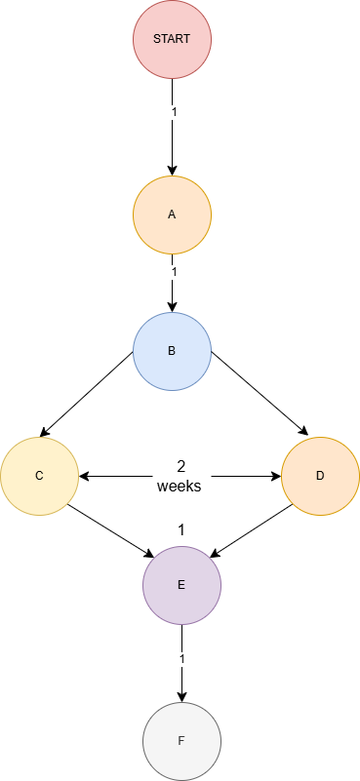
Network diagram
License, Design Quality & SDG Relevance
To ensure the project has clear usage rights while protecting your intellectual property, the following licensing structure is defined:
License Selection: MIT License
The MIT License is selected for HydroAlert SL. It is a permissive open-source license that allows for rapid scaling, modification, and deployment by local water authorities, non-governmental organizations (NGOs), and community developers in Sierra Leone, while protecting the original creators from liability.

Copyright (c) 2026 Clifford Joshua Jones ,JANE SARAH BANGURA and ISMATU KAMARA
Permission is hereby granted, free of charge, to any person obtaining a copy
Of this software and associated documentation files (the "Software"), to deal
In the Software without restriction, including without limitation the rights
To use, copy, modify, merge, publish, distribute, sublicense, and/or sell
Copies of the Software, and to permit persons to whom the Software is
Furnished to do so, subject to the following conditions:
The above copyright notice and this permission notice shall be included in all
Copies or substantial portions of the Software.

Attribution of External Resources
The system leverages open-source resources, which are credited appropriately:
- Mapping Services: the Google Maps API, utilizing standard map styling guidelines to visualize regional water infrastructure, powers Map data and rendering.
- Iconography: UI icons (Dashboard, Pumps, Alerts, Technicians, Profile) are adapted from open-source libraries (such as Google Material Symbols or Font Awesome) under the SIL Open Font License / MIT License.
Design Quality (UI/UX Analysis)
The mobile interface exhibits high design quality, balancing administrative management tools with frictionless field technician operations.
Visually Consistent Design System
Cohesive Palette: The application features a clean, high-contrast palette. A primary corporate blue (#1976D2 variant) establishes professional trust, paired with a soft gray background that minimizes glare for field workers operating in bright daylight.
Semantic Color Logic: Status indicators utilize immediate, universally understood colors to convey urgency without crowding the UI:
Red / Faulty: Instant warning state for pumps needing critical intervention (e.g., Kambia Village Pump showing "No water flow detected").
Orange / In Progress / Under Repair: Indicates active maintenance triage, tracking time metrics like an estimated arrival of 45 minutes.
Green / Functional / Completed: Visually confirms operational health and successful maintenance resolution.

User-Friendly Interface & Clean Navigation
Persistent Global Navigation: A 5-tab bottom navigation bar (Dashboard, Pumps, Alerts, Technicians, Profile) gives users single-tap access to core modules, preventing deep hierarchy confusion.
Information Scannability: Complex relational data is separated into card-based layouts. For instance, the Pump Details view cleanly segregates structural telemetry metadata from the weekly performance trend chart, while the Dashboard uses large, prominent numeric text to show overall health checks at a glance.
Optimized Mobile Interactions: Buttons use clear semantic verbs ("Mark as Completed", "Update Status", "Assign") with distinct tactile spacing, reducing accidental input errors for technicians handling field equipment.

United Nations SDG Relevance & Impact
HydroAlert SL directly aligns with the United Nations Sustainable Development Goals (SDGs), addressing real-world clean water infrastructure vulnerabilities through proactive digital management. This particular project is a combination of 3 different SGDs
PRIMARY ALIGNMENT: SDG 6 - CLEAN WATER & SANITATION
Achieve universal and equitable access to safe and affordable drinking water.
SDG 9: Industry, Innovation Infrastructure & Communities
Upgrading rural infrastructure, reducing down-time of vital
Using smart IoT telemetry.
SDG 11: Sustainable Cities & Communities
reducing down-time of vital , communal resource lifelines.
Real-World Problem-Solving Value
Mitigating Water Scarcity Delays: Rural and regional communities across Sierra Leone depend entirely on local communal pumps. Traditional manual reporting methods mean a pump failure can go unnoticed by central supervisors for weeks. HydroAlert SL transforms this from a reactive process to an automated, real-time dispatch cycle.
Data-Driven Accountability: By mapping every asset—tracking sensor batteries and displaying a 7-day activity degradation loop—the system provides municipal stakeholders with hard data regarding regional infrastructure health.
Empowering Local Workforce Capabilities: The application acts as a logistical bridge, matching mechanical failures to local technicians based on geographic distance and route urgency. This structural organization decreases pump downtime, ensuring that reliable, clean drinking water remains constantly available to community reside

CONCLUSION
HydroAlert SL provides an integrated approach to sustainable public infrastructure management. By shifting water point maintenance from a reactive system to an automated, telemetry-driven workflow, the platform addresses prolonged repair delays in rural communities. The Agile-based software cycle ensures scalability, while the 4-tier system architecture bridges physical hardware and user applications smoothly. Supported by a clear design philosophy, open-source compliance, and explicit tracking metrics, HydroAlert SL demonstrates how digital public good platforms can provide data-driven management and improve community resources.

REFERENCES
- Sommerville, I. (2015). Software Engineering (10th ed.). Pearson. (Framework principles for system architectural layer modularity and software lifecycle execution).
- Beck, K., Beedle, M., van Bennekom, A., Cockburn, A., Cunningham, W., Fowler, M., ... & Kern, J. (2001). Manifesto for Agile Software Development. (Structural guide for iterative development sprints and user narrative definitions).
- United Nations. (2015). Transforming our world: The 2030 Agenda for Sustainable Development. Bureau of International Affairs. (Strategic markers supporting clean sanitation frameworks under SDG 6, 9, and 11).
- Fielding, R. T. (2000). Architectural Styles and the Design of Network-based Software Architectures. University of California, Irvine. (Standards regarding structural component interaction patterns using stateless REST endpoints over HTTP protocols).

